# Variables and Types

## Exercises

### Week 2

Prior to attempting these exercises ensure you have read the lecture notes and/or viewed the video, and followed the practical. You may wish to use the Python interpreter in interactive mode to help work out the solutions to some of the questions.

Download and store this document within your own filespace, so the contents can be edited. You will be able to refer to it during the test in Week 6.

Enter your answers directly into the highlighted boxes.

For more information about the module delivery, assessment and feedback please refer to the module within the MyBeckett portal.

**_________________________________________________________________________**

## ©2021 Mark Dixon / Tony Jenkins

Which is the purpose of a *variable* within Python?

*Answer:A variable within Python is used to store a value.*

**_________________________________________________________________________**

Write a simple Python statement that creates and assigns a value of 3.142 to a variable called ‘pi’

*Answer:pi=3.142*

**_________________________________________________________________________**

Which of the following is **NOT** a valid name for a variable within Python?

total

result

question?

name_1

*Answer:question?*

**_________________________________________________________________________**

Following the execution of the code below, what will be stored in the variable 'age'?

age = 10 + 20

age = age + 5

*Answer:35*

In the answer box below write the *exact* output that would be displayed if the following statement was executed (assuming age has been created as in the previous question):

print("The age value is",age)

*Answer:The age value is 35*

**_________________________________________________________________________**

Which of the following is an example of an **Augmented Assignment** in Python?

total = 20

total = total + 5

total *= 100

total = max

*Answer:*total *= 100

**_________________________________________________________________________**

Which of the following is an example of an **integer** type variable?

result = "xyz"

result = 20

result = 20.5

result = False

*Answer:*result = 20

**_________________________________________________________________________**

What are the only two legal values of a **boolean** type variable?

*Answer:True and False*

**_________________________________________________________________________**

Following the execution of the code below, what will be the *data-type* of the variable 'average'?

average = total / count

*Answer:float*

**_________________________________________________________________________**

Following the execution of the code below, what will be the *data-type* of the variable 'message'?

message = "hello there!"

*Answer:string*

**_________________________________________________________________________**

What determines the current data-type of a variable?

*Answer:type() function*

**_________________________________________________________________________**

What is the purpose of the built-in type() function?

*Answer:Type() function is used to get the type of an object.*

**_________________________________________________________________________**

What would be the output following execution of the following code?

type(10.2)

*Answer: ‘float’*

**_________________________________________________________________________**

Does the Python language support *Dynamic Typing*, or *Static Typing*?

*Answer:dynamic typing.*

**_________________________________________________________________________**

Which of the following is an example of a *function call*?

answer = 10

print(answer)

total *= 10

10 + 20

*Answer:print(answer)*

**________________________________________________________________________**

What is the name given to the values that are passed to a function within the parentheses?

*Answer:*Parameters

**_________________________________________________________________________**

What is the purpose of the built-in input() function?

*Answer: It is used to take input from users in string.*

**_________________________________________________________________________**

What is the data-type of the value returned by the input() function?

*Answer: string*

**_________________________________________________________________________**

Use the Python interpreter to input a small Python program that prints your name and address on the screen. Once this works type the program in the answer box below.

*Answer:*

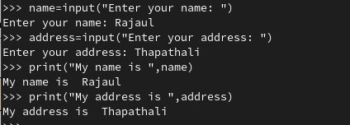

**_________________________________________________________________________**

Within the answer box below write a small Python program, that when run, would print the following message including the double quotes -

Hello, is your name "Bwian"?

*Answer:*

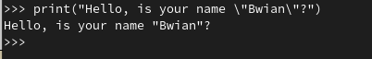

Now write a second small Python program, that when run, would print the following message including the single quotes -

Or is your name 'Woger'?

*Answer:*

**

**_________________________________________________________________________**

Within the answer box below write a small Python program, that when run, uses *escape sequences* to print the following text exactly.

This is a string containing a backslash (\),

a single quote ('), a double quote (")

and is split across multiple lines

*Answer:*

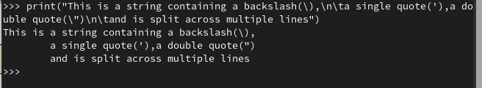

**_________________________________________________________________________**

Within the answer box below write a small Python program, that when run, uses *triple quotes* to print the following text exactly.

This is a string containing a backslash (\),

a single quote ('), a double quote (")

and is split across multiple lines

*Answer:*

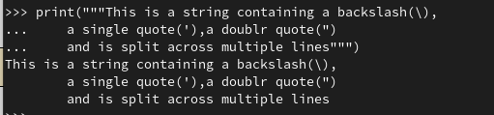

**_________________________________________________________________________**

Use the Python interpreter to input a small Python program that asks the user to input a temperature in fahrenheit. Once the value has been input, display a message that shows the same temperature in celsius. You may have to do some research in order to find out the conversion method. Once this works, type the program in the answer box below.

*Answer:*

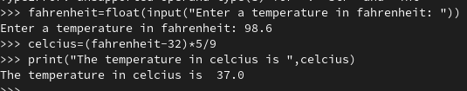

**_________________________________________________________________________**

Within the answer box below write a small Python program that asks the user to enter two values. Store these in variables called 'a' and 'b' respectively.

*Answer:*

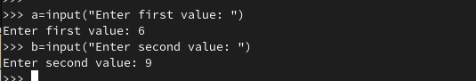

Once the values have been input use three calls to the print() function to show output such as the following (in this example the user entered *10.2* and *18.3*) -

The value 'a' was 10.2 and the value 'b' was 18.3

The sum of 'a' and 'b' is 28.5

The product of 'a' and 'b' is 186.66

*Answer:*

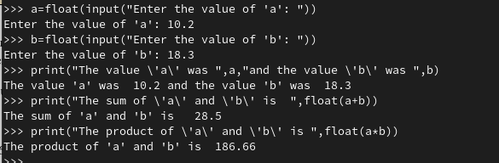

**________________________________________________________________________**

Python includes a built-in function called **max()**. When this is called with multiple argument values it returns the largest of the given arguments. e.g.

max(20, 50, 30) # this would return 50

Within the answer box below write a small program that asks the user to input three values. Store these in variables (the names are up to you) then use the **max()** function to display the largest of the input values.

*Answer:*

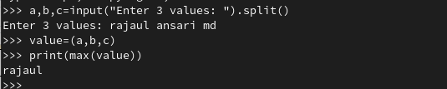

Using the Python interpreter execute your code, then examine the output generated when the input the values are 'hello', 'welcome', and 'bye'

Does the program still show the maximum value? If not, what does it show?

*Answer: Yes, the program still shows the maximum value , it shows welcome.*

**_________________________________________________________________________**

Given the following definition:

name = "Black Knight"

What would each of the following Python statements display?

print( name[0] )

*Answer:B*

print( name[4] )

*Answer:k*

print( name[-1] )

*Answer:t*

print( name[-2] )

*Answer:h*

print( name[2:5] )

*Answer:ack*

print( name[6:] )

*Answer:Knight*

print( name[:5] )

*Answer:Black*

print( name[:] )

*Answer:Black Knight*

**_________________________________________________________________________**

Which of the following creates a variable containing a **List**?

names = "Terry"

names = 10

names = [ "Mark", "Jon", "Amanda", "Edward", "Sally" ]

names = "Mark", "Jon", "Amanda"

*Answer:*names = [ "Mark", "Jon", "Amanda", "Edward", "Sally" ]

**_________________________________________________________________________**

Is the following a valid **List**, even though it contains values based on different data-types?

values = [10.2, "Jon", False, "Edward", True ]

*Answer:Yes*

**_________________________________________________________________________**

If a value is **mutable**, can it be modified after it has been created?

*Answer: yes*

**_________________________________________________________________________**

What term is used to describe a value that cannot be changed once it has been created?

*Answer:Immutable*

**_________________________________________________________________________**

Is a List **mutable** or **immutable**?

*Answer:Mutable*

**_________________________________________________________________________**

Is a String **mutable** or **immutable**?

*Answer:Immutable*

**_________________________________________________________________________**

Given the following definition -

names = ["Terry", "John", "Michael", "Eric", "Terry", "Graham"]

What would each of the following Python statements display?

print( names[2] )

*Answer: Michael*

print( names[-2] )

*Answer:Terry*

print( names[0:3] )

*Answer:['Terry', 'John', 'Michael']*

names = names + "Brian"

print( names )

*Answer: can not concatenate list to string.*

names[0:1] = ["Mark", "Jon"]

print( names )

*Answer:* ["Terry", "John", "Michael", "Eric", "Terry", "Graham"]

**_________________________________________________________________________**

What built-in function within Python can be used to find out how many elements are contained within a string or list?

*Answer: len() function*

**_________________________________________________________________________**

## **Exercises are complete**

Save this logbook with your answers. Then ask your tutor to check your responses to each question.